Name: Manahil Habib
Section: 5-B
Reg no: 2023-BSE-042
Lab 4
Task 1
Confirm the VM resources that were allocated in Lab 1
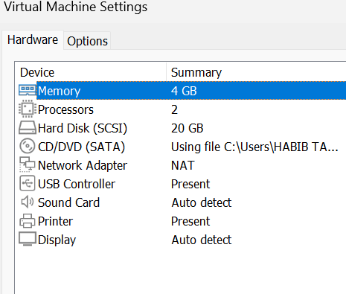
Task 2
Use a single preferred host-terminal method to connect to the VM. Do not switch between methods during the task
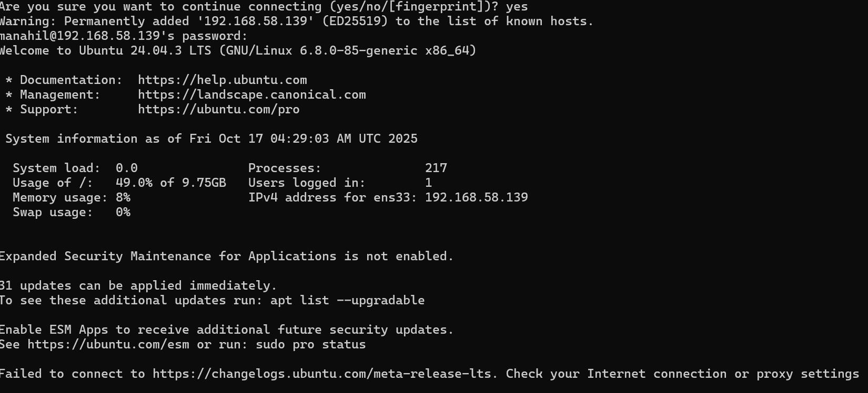
Whoami, pwd:
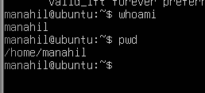
Task 3
- List root directory contents:
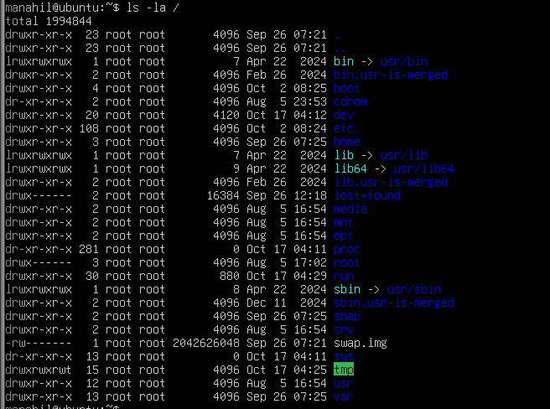
- View OS release information
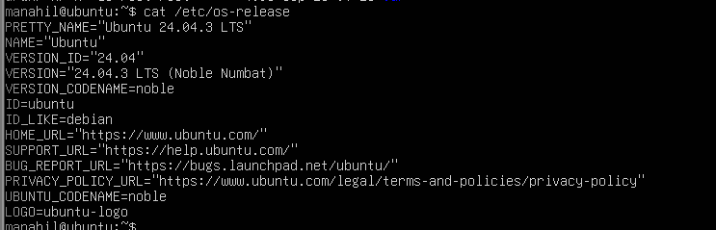
- Inspect these directories (run each command and screenshot the output):
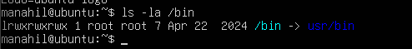

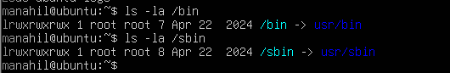
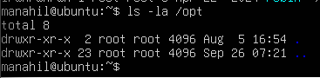
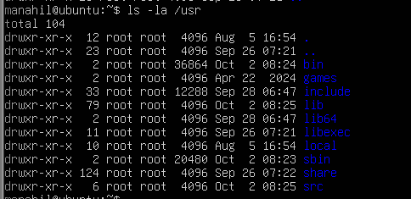
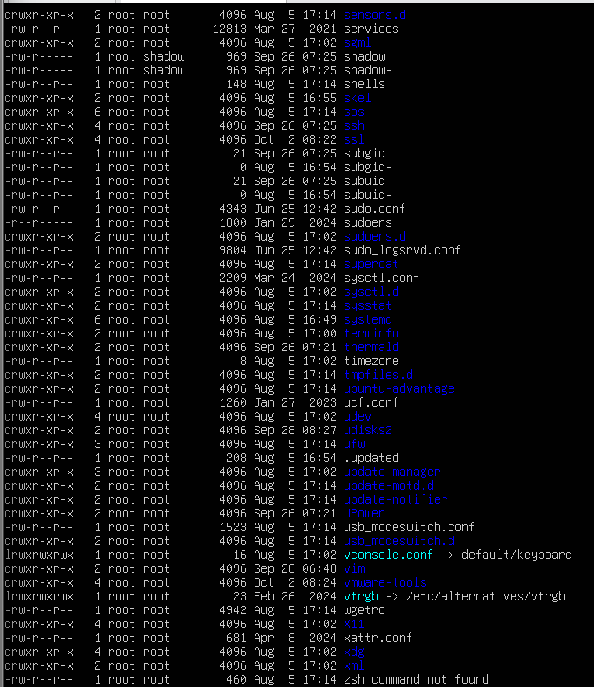

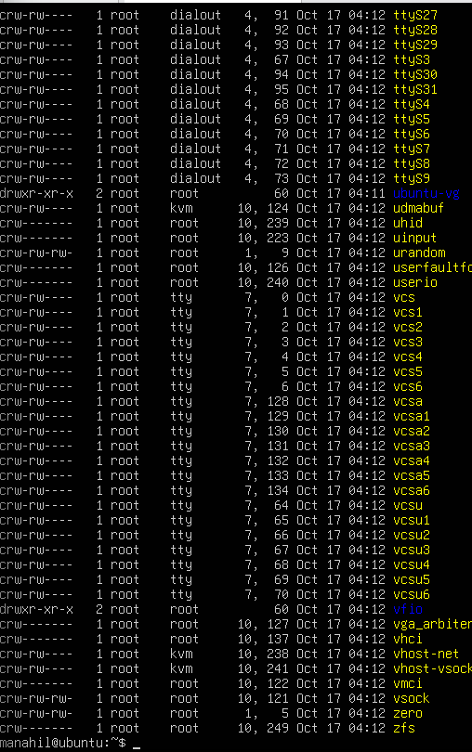
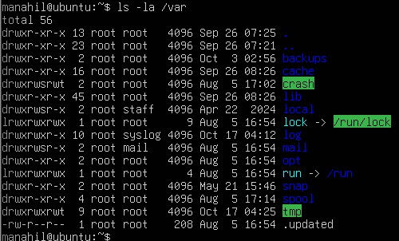
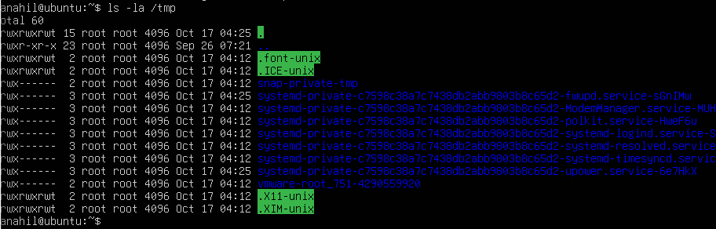

- List your home directory and show hidden (dot) files:
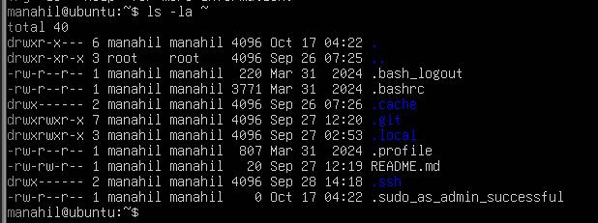
- Write a short paragraph (3–5 sentences) that explains the difference between /bin, /usr/bin and /usr/local/bin. Open your editor:

Task 4

- Create a workspace and navigate:
Pwd
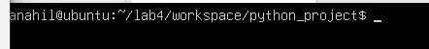
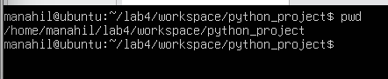
- Create files using an editor (open each editor session and save a screenshot showing content):
nano README.md
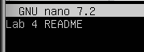
nano main.py
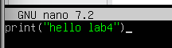
nano .env
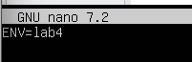
- List files and capture:
ls -la
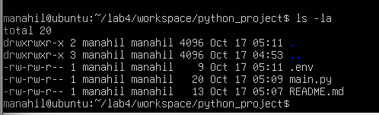
Copy, move and remove:
mkdir -p ~/lab4/workspace/java_app
cp -r ~/lab4/workspace/python_project ~/lab4/workspace/java_app_copy
ls -la ~/lab4/workspace
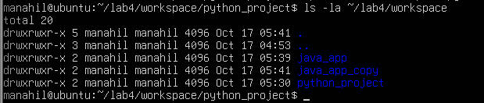
- Use command history and tab completion:
History
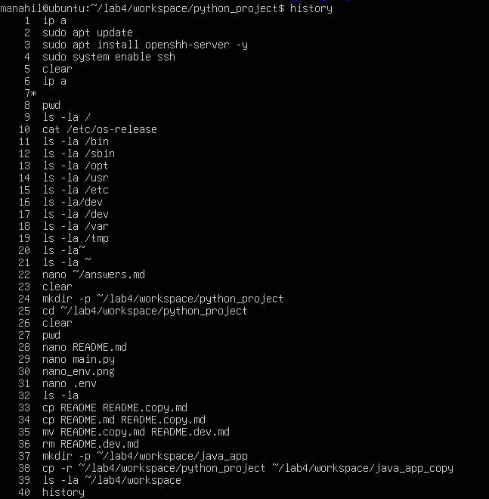
- Demonstrate tab completion (type partial name and press Tab) and capture that action as tab_completion.png.

Task 5
- Kernel and OS:

- CPU (ensure model name visible):
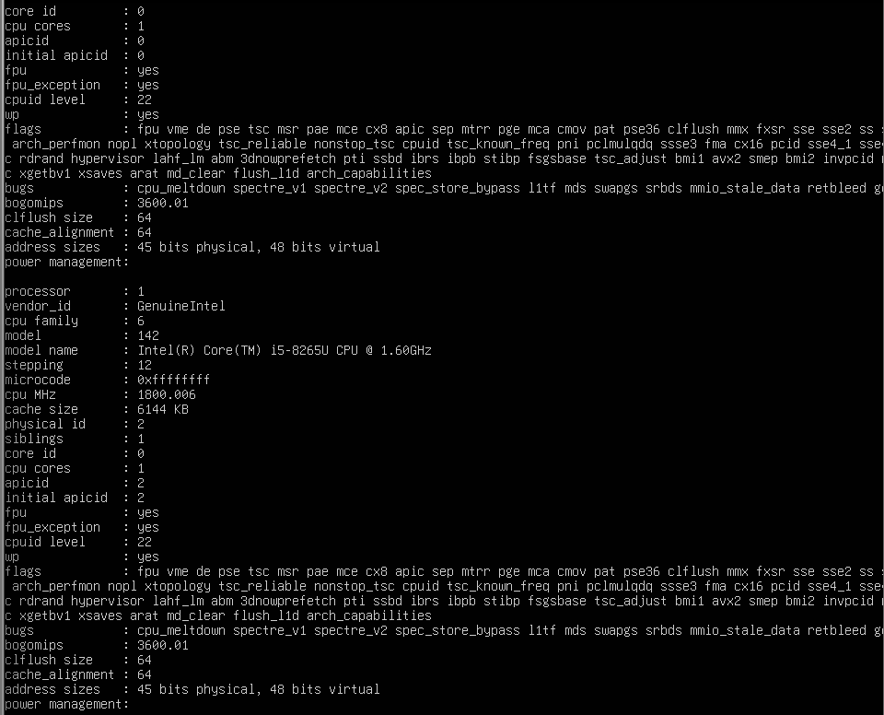
- Memory:
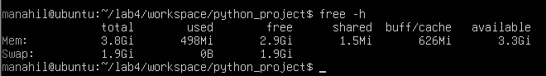
- Disk:
df -h
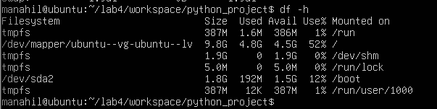
- Os Release:
cat /etc/os-release
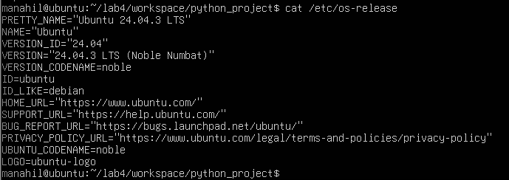
- Processes (show top lines of ps output):
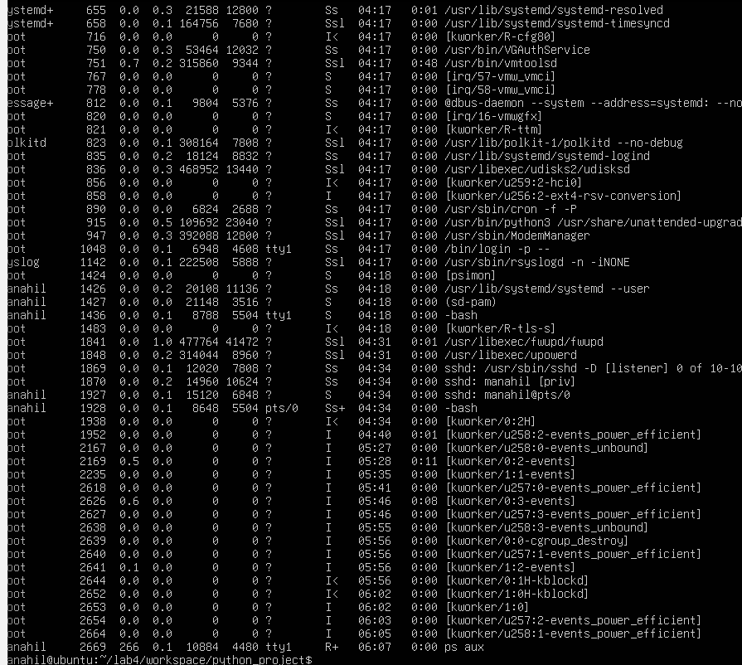

Task 6
- Create a new user named lab4user:
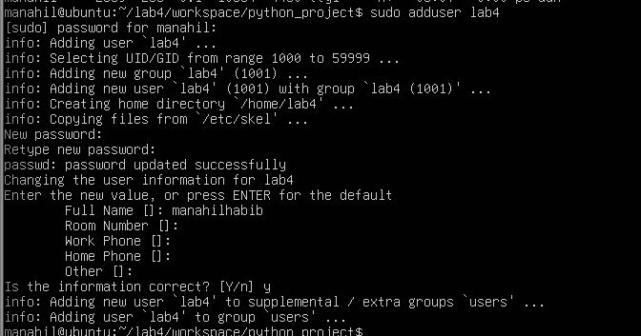
- Verify the user entry:
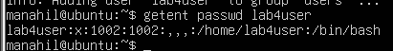
- Switch to the new user to verify login:
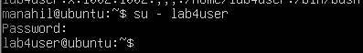
- From the new user you may attempt a sudo command to show that sudo is not available for this account (expected failure), e.g.:
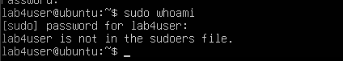
- Return to the original user:
Exit
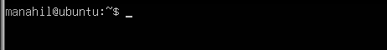
- (Optional) Remove the test user when finished:
sudo deluser --remove-home lab4user
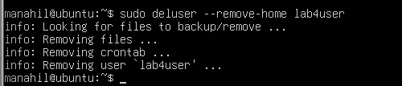

Task 7

Create a small demo script using an editor and run it
This task is optional — complete it for extra practice or extra credit. It is not required for passing the core lab tasks.
Steps (inside VM)
- Open an editor to create the script:
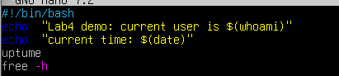
- Make the script executable:
- Run the script as your regular user:
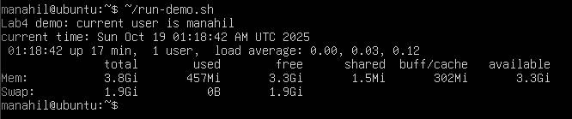
- Optionally run it with sudo:
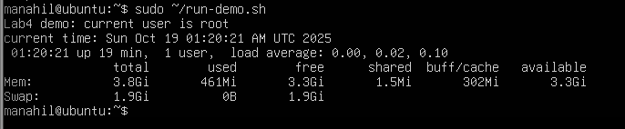

Exam Evaluation Questions

1. Remote Access Verification (Cyber Login Check)
Scenario:
You are part of a SOC (Security Operations Center) investigating unauthorized access to a Linux server hosted on VMware. Prove you can securely connect and verify your identity.
Steps:
- Connect to the Ubuntu VM remotely from your host terminal.

- Verify your current user and home directory path.
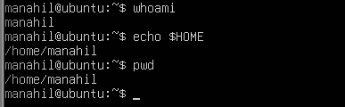
- Confirm you are connected to the correct host machine.
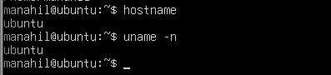

2. Filesystem Inspection for Forensic Evidence
Scenario:
The incident response team suspects malicious files in system directories. You must explore the filesystem to locate and document the system’s structure.
Steps:
- Display the contents of the root directory.
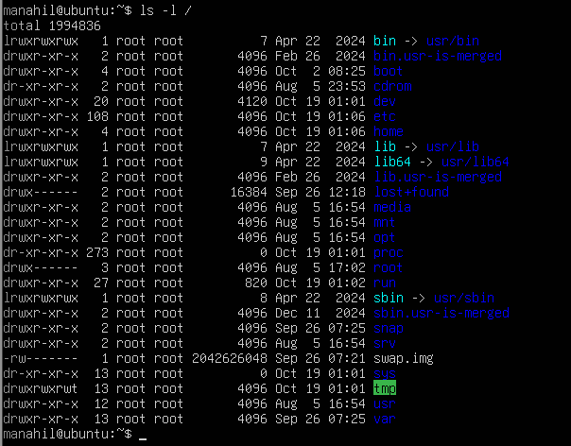
- Display the OS version and release information.
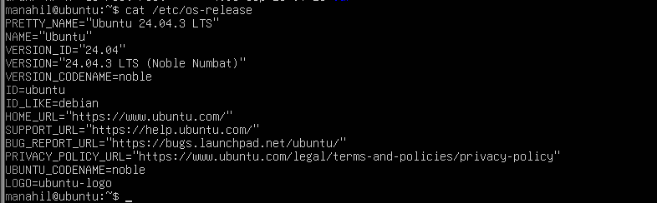
- Explore and record directory listings for /bin, /sbin, /usr, /opt, /etc, /dev, /var, and /tmp.
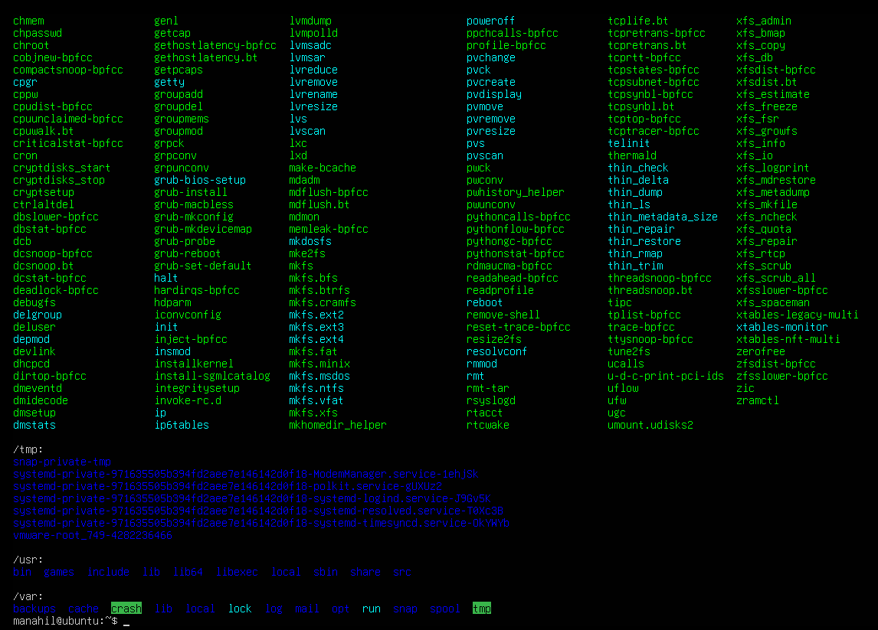
- Display all hidden files in your home directory.
- Create a markdown file summarizing your findings on key binary directories.

3. Evidence Handling & File Operations
Scenario:
You are creating a sandbox environment to safely analyze and handle suspicious files collected from a compromised system.
Steps:
- Create a structured folder hierarchy under your home directory for analysis.
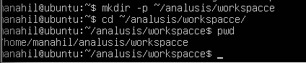
- Create three text files, including one hidden file, in your workspace.
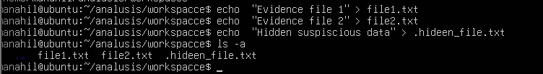
- Create a backup copy of one file, rename it, and then delete it after verification.
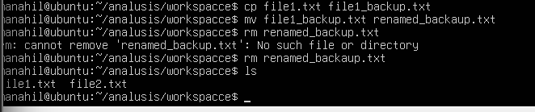
- Copy the entire workspace as an evidence backup folder.
- Display your command history to document all actions performed.
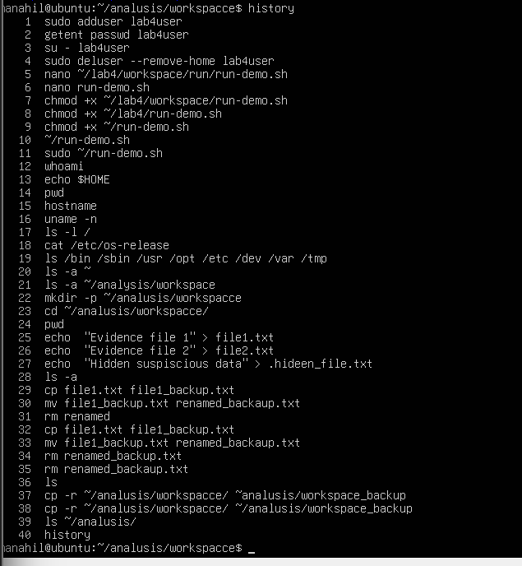
- Demonstrate Linux auto-completion by typing a partial command or filename.

4. System Profiling and Process Monitoring
Scenario:
You are investigating a potential malware infection that is consuming excessive resources on the Linux VM.
Steps:
- Display the system’s OS and kernel version for the investigation report.
- Display CPU, memory, and disk usage information.
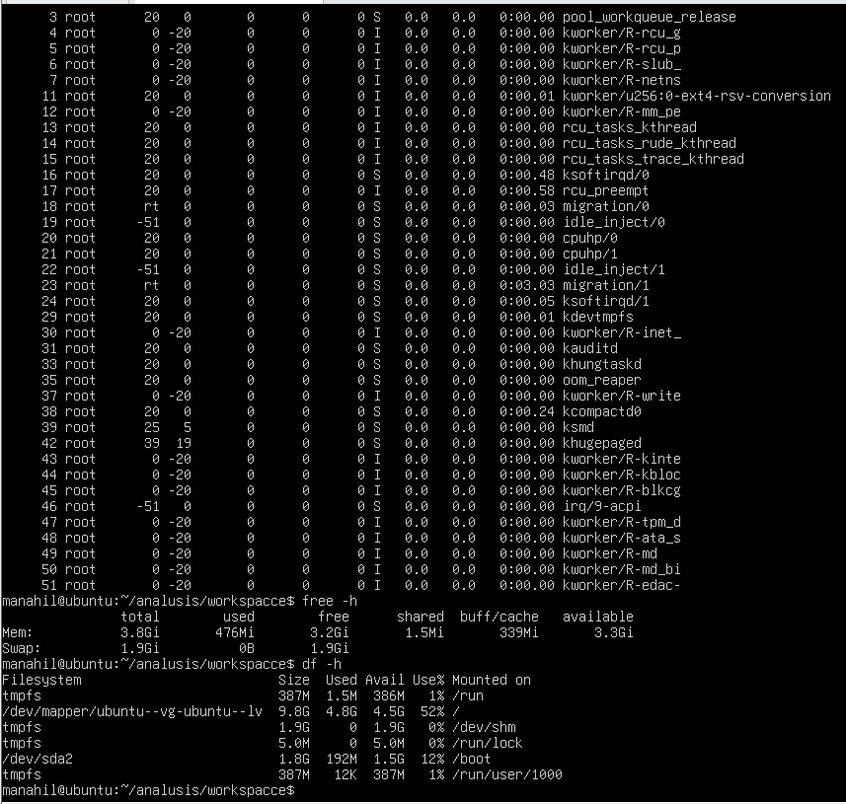
- Display all active running processes to identify suspicious activity.
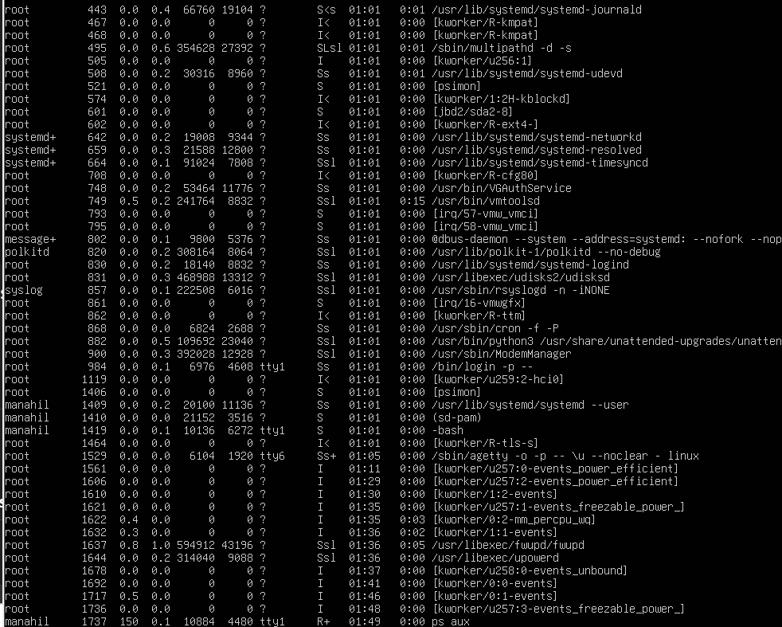

5. User Account Audit & Privilege Escalation Simulation
Scenario:
You are performing a user activity audit on a compromised Linux server.
The SOC suspects a newly created account (lab4user) may have been used for unauthorized access.
Your task is to simulate the account creation, perform privilege tests, and analyze authentication logs for forensic evidence.
Steps:
- Create a new test user named lab4user.
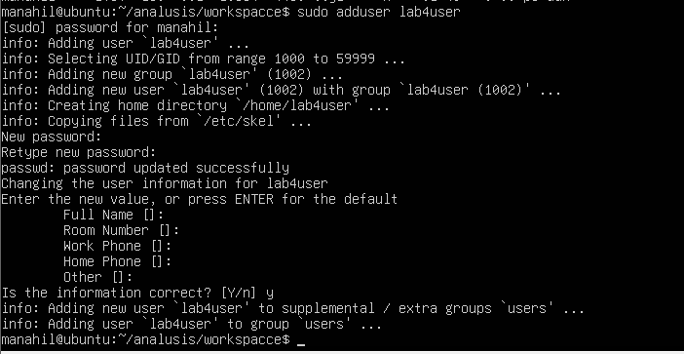
- Verify that the new user record exists in the system’s user database.
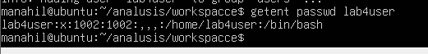
- Log in as lab4user and confirm successful login.
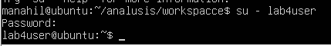
- Attempt to run an administrative command as lab4user (expect permission denied).
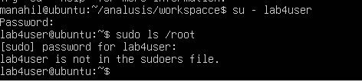
- Switch back to your main analyst account.
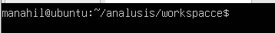
- Inspect the system authentication logs located at /var/log/auth.log to determine whether the lab4user account attempted any logins (successful or failed).
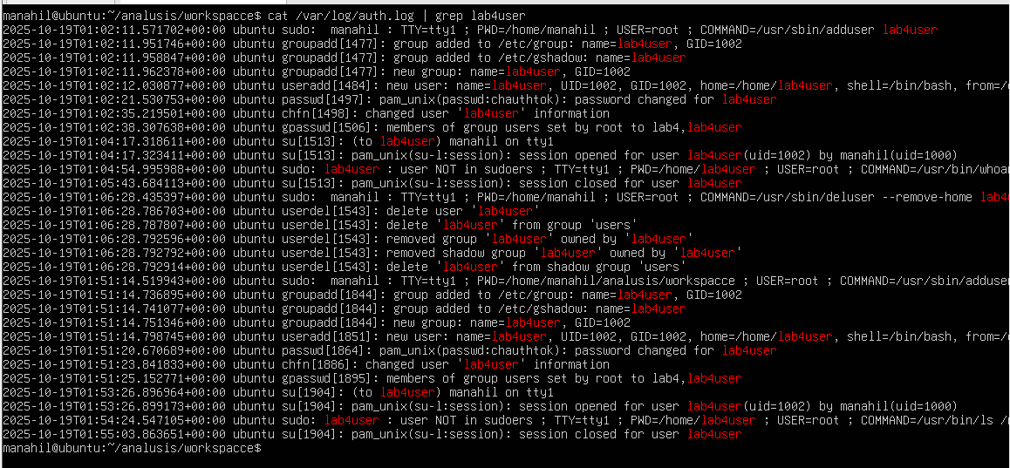
- (Optional) Remove the lab4user account after the audit and verify deletion.




